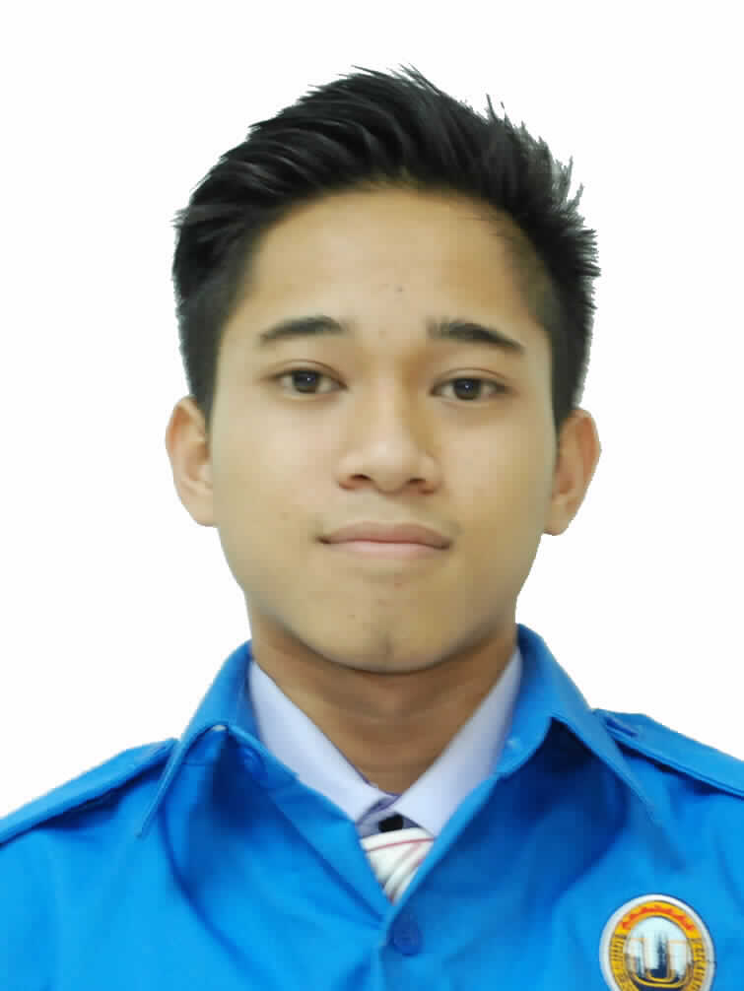
AMIR KHAIRUDDIN B ZULKIFLI
PERSONAL DATA

NRIC : 961001-11-5233
Date Of Birth : 1 October 1996
Gender : Male
Mailing Address : 3170 KAMPUNG TOK HAS,22000 JERTEH,TERENGGANU
Telephone number : 0111-2269957
Email : gdboyz96@gmail.com
Marital Status : Single
Health : Excellent
Languages : Bahasa Melayu , English and Mandarin (Basic)

OBJECTIVE

To get a job that fit with my skill.

SKILLS
Languages | Bahasa Melayu , English
Programming | C++(BASIC) , Microsoft Visual Basic(BASIC) , PHP Web Programming, Laravel (Basic)

EDUCATION
Years | Institute | Qualification
2014 - Current | Diploma in Information Technology  Universiti Kuala Lumpur | CGPA : 2.81
2012 - 2013 | SMKA NURUL ITTIFAQ | SPM : PASS

CO-CURRICULAR ACTIVITIES
Date | Activities
9 December 2015 | Intern Mandarin song performance at UniKL’s Bestari Hall
15 November 2014 | Community self-help at Bagan Lalang Beach
2 November 2014 | MPM CUP Unikl Futsal Tournement

WORKING EXPERIENCE
Date | Organization | Position
May 2015 - August 2015 | PBC TELECOMMUNICATION | Customer service
Feb 2017-June 2017 | EASTER CALIPH ENTERPRISE | Internship  (Programmer)

ACHIEVEMENTS
Date | Achievements
March 2012 | Digital Etiquette
March 2012 | Basic course in building & organising content in web  (certificate by intel)
September 2015 | Basic course computer assembly  (certificate by intel)

